**VLAN Based Network**

Brian Moyles – 21333461

VLAN System and switch configuration

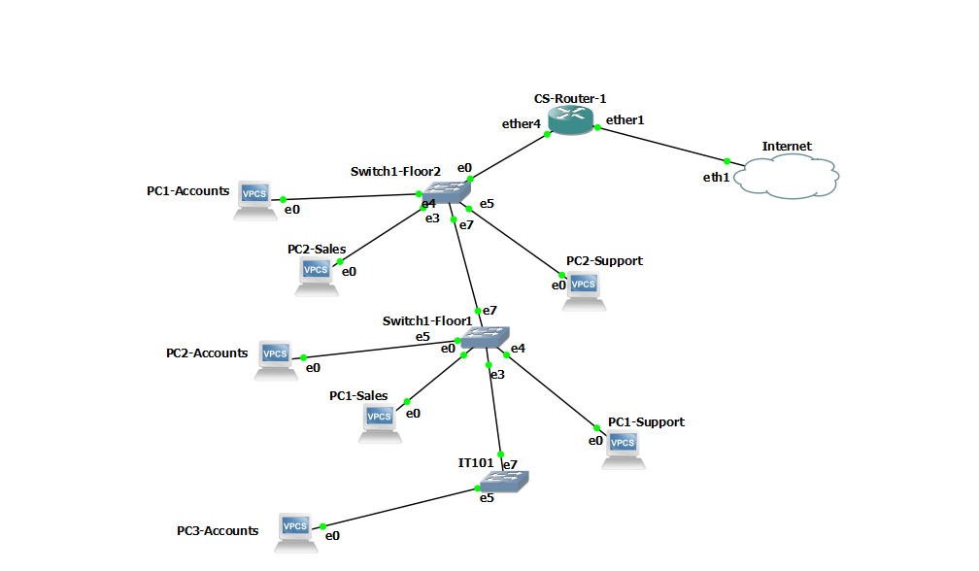

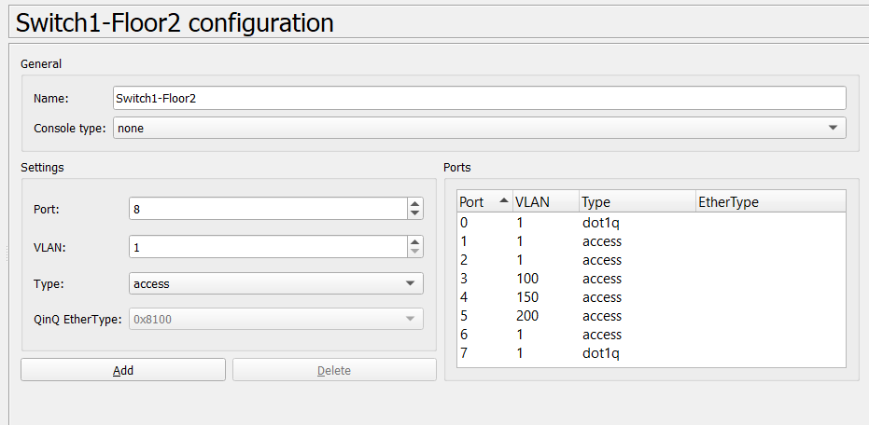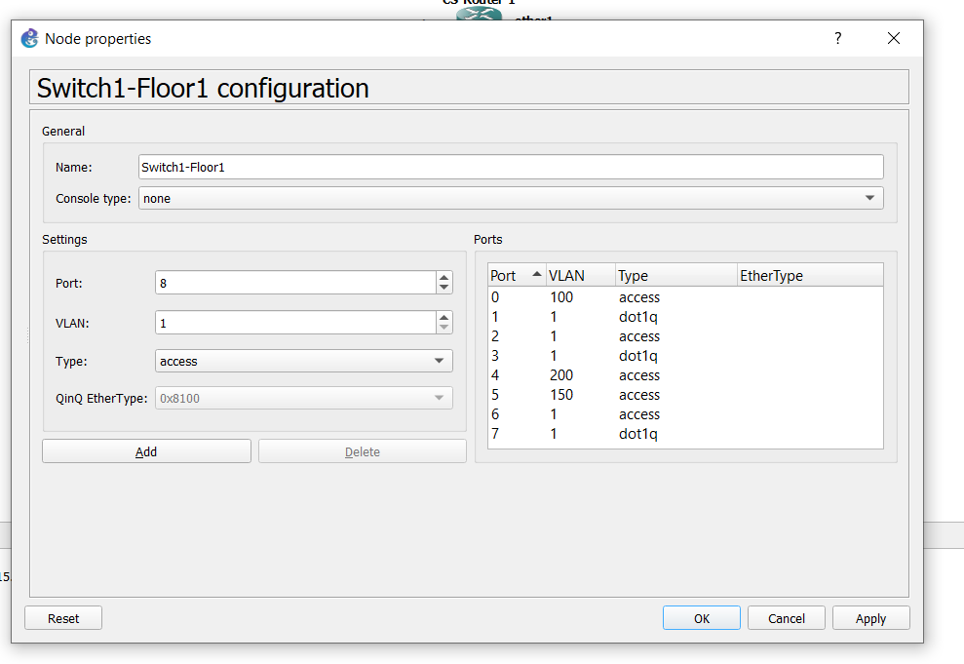

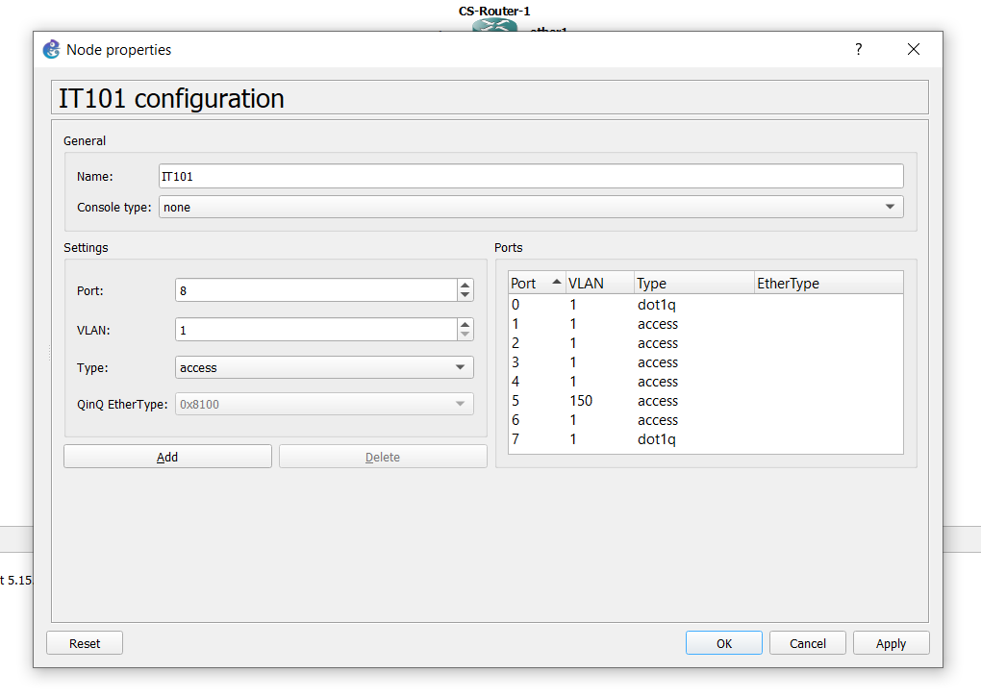

Pinging the VPCs in the accounts VLAN

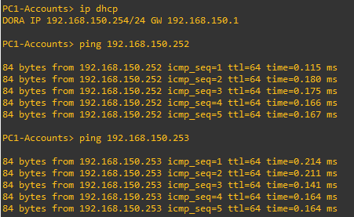

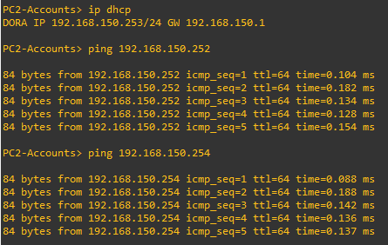

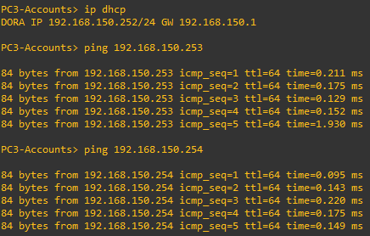

It is shown that PC3-Accounts, which is connected to the it101 switch, can be pinged by the other 2 VPCs in the Account VLAN. The PC1 and PC2 VPCs in the Accounts VLAN can also ping each other. This verifies that the VPC devices in Accounts VLAN work.

Run a Trace Route from one VPC to another within the same VLAN



PC3-Accounts (192.168.150.252) runs a trace to PC2-Accounts (192.168.150.253). As the VPCs are on the same VLAN, it is directed by the switch to the correct VPC with only 1 hop.

Run a Trace Route from one VPC to another in a different VLAN

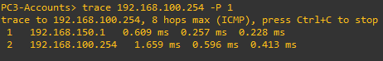

As the VPC is on another VLAN, 2 hops are necessary to reach the destination. The first hop is to the gateway at 192.168.150.1. The second hop is to the destination at 192.168.100.254. The second hop is required to reach a VPC in a different VLAN.

Packet Capture on Link connecting Switch to Router

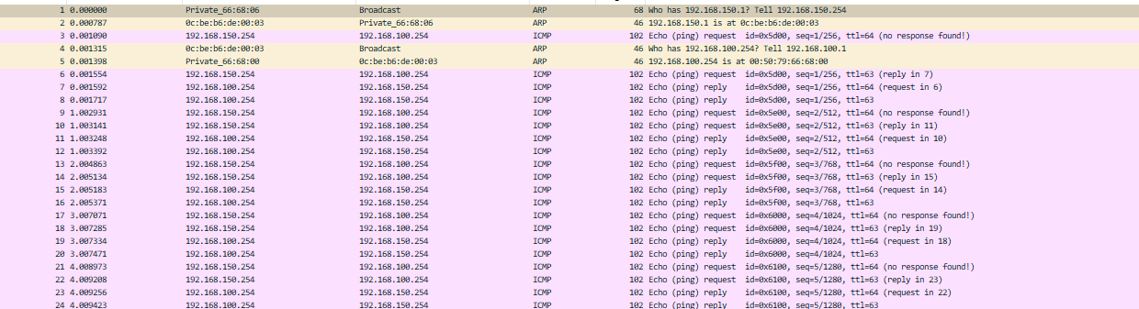

* Ping from 192.168.150.254 to 192.168.100.254

The first ARP packet is a request asking for the MAC address associated with a specific IP. As 192.168.150.1 is the gateway for 192.168.150.254, it is requesting the gateway MAC address.

The second ARP packet is a reply to the first ARP request. It shows the MAC address of the gateway required.



The VPC on VLAN150 sends a ping request to the target destination.



The gateway for the Destination VPC in the VLAN100 then sends an ARP request to find the MAC address for the destination VPC. It then gets an ARP response telling the gateway the MAC address for 192.168.100.254



The VPCs can then ping and reply to each other. There is 2 hops involved in each request and reply

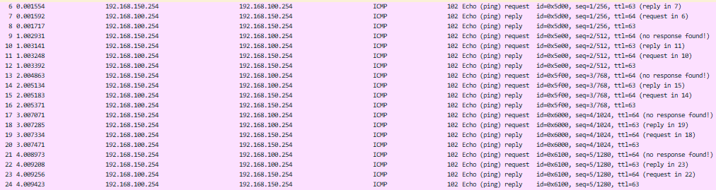

802.1q is VLAN tagging. It adds an ID which allows you to know which VLAN you are in.

Here, we are in VLAN 150

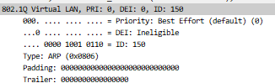

Here, we are in VLAN 100

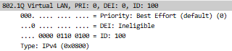

It allows for the correct routing between the VLANs.